### **Mics**

### **1. Welcome**

Difficulty: Easy/ 50 points

**Description:**

WELCOME TO NOCTIVUS NULL CORE CTF

JOIN OUR DISCORD SERVER TO VERIFY AND OBTAIN THE FLAG:-<https://discord.gg/uUTpXuRJ>

**Solution:**

Joined the Discord. Explored #community — found the flag pinned

Flag: **NOCT{WELCOME_To_NULL_CoRe}**

### **2. RICK ROLL**

Difficulty: Easy/ 100 points

**Description:**

now you know the rules only one way to win is to take a look at rick’s words

{Never gonna give you up Never gonna let you down Never gonna run around and desert you Never gonna make you cry Never gonna say goodbye Never gonna tell a lie and hurt you}

**Solution:**

The challenge hints that the only path to victory lies in analyzing Rick’s words carefully. A closer inspection reveals a subtle clue — for instance, the word **'Never'** stands out with its capital 'N', possibly indicating its significance.

#### **Flag: NOCT{NNNNNN}**

### **3. Meta Mama**

Difficulty: Easy/ 100 points

**Description:**

Ethey... Insta la bot ah? 👀 There’s something strange about the Instagram account: @neuxdemorphous At first glance, it looks like a normal page — but beneath the surface, there’s something hidden.

**Solution:**

*While exploring the challenge, I came across an unusual hint referring to the Instagram account* ***@neuxdemorphous****. At first glance, it appeared like a regular profile, but the bio* ***“love is god”*** *felt oddly cryptic — possibly a clue.*

*Out of curiosity, I sent a direct message to the account. To my surprise, it replied instantly, hinting at some kind of automated bot behind the scenes.*

*The response included the phrase* ***“terrifying NOCTORIAN DRAGON”****, which seemed intentionally emphasized — possibly the next clue or part of the flag.*

Flag: **NOCT{NOCTORIAN_DRAGON}**

### **4. The Mighty Paul**

Difficulty: Easy/ 100 points

**Description:**

Forget payloads. Forget Wireshark. This time, the only thing standing between you and the flag... is pure testosterone.

Straight from the mystical lands of China, The Mighty Paul has trained for this moment his whole life. While others brute-force passwords, Paul brute-forces people.

He doesn’t speak much. He doesn’t need to. His forearm does the talking — and occasionally the crushing.

**Challenge:** Face Paul in a real-life arm wrestling duel. Win, and something very interesting might come your way.

How to Play:

Walk up to the arena.

Sit. Lock hands. Try not to scream.

Wrestle. Win. Profit.

Don’t ask where the flag is. Just believe.

Remember he doesn't talk.

**Solution:**

Defeat the Chinese challenger in an arm-wrestling match. Face him, win the duel, and obtain the flag from his hand.

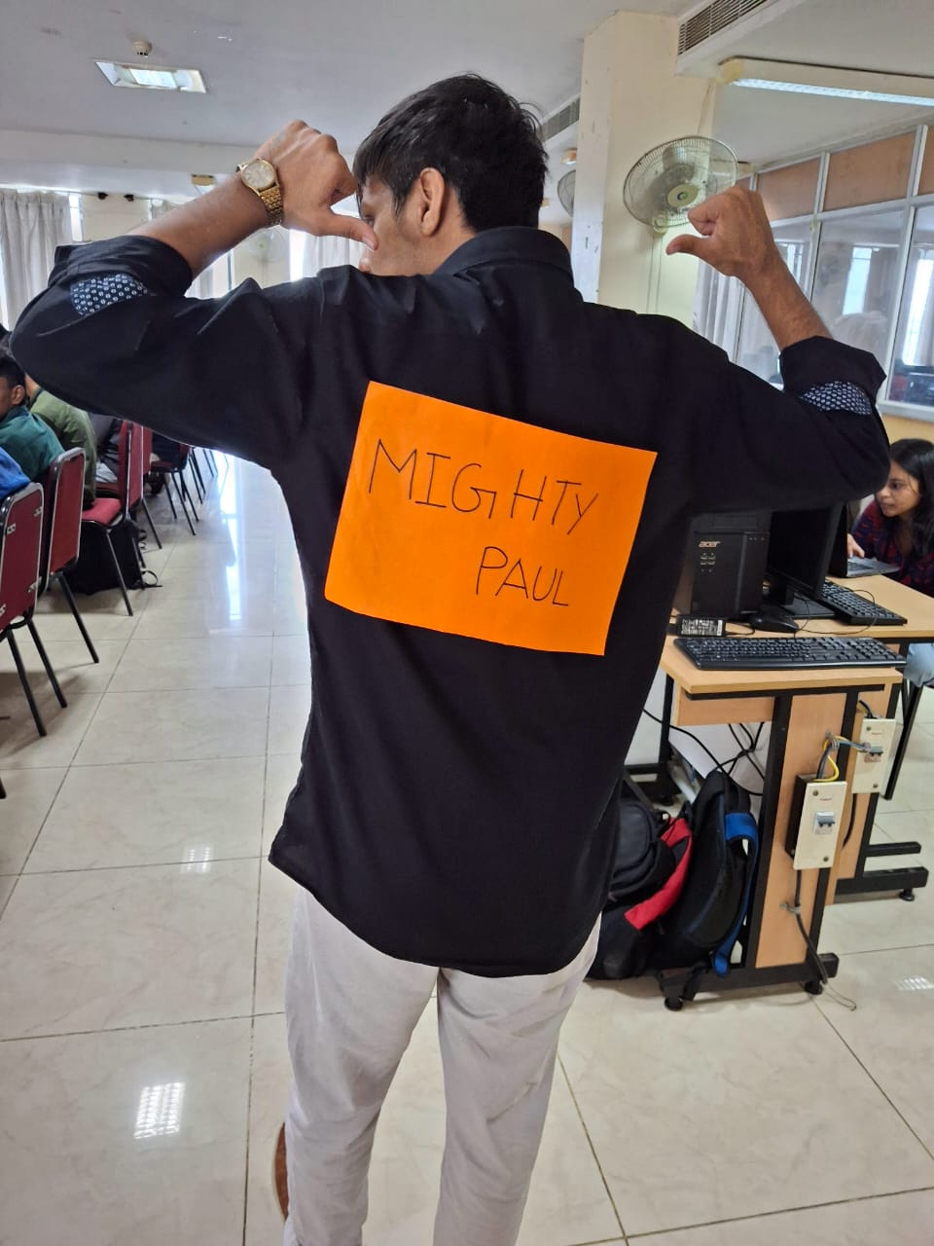

Flag: **NOCT{earned_with_sweat}**

**5. Weeb God**

Difficulty: Easy/ 200 points

**Description:**

find the english sub for this scene yes its time for you weebs to since good luck :))))

**Solution:**

The challenge gave a picture that looked like a scene from an anime, along with the hint “find the English subtitle.” I tracked down the exact episode, watched it carefully, and sure enough there it was.

Flag: **NOCT{Nika, the Sun God!}**

**6. Mudinja Kandupudi 👀**

Difficulty: Medium/ 200 points

**Description:**

Someone uploaded something they shouldn't have. The video looks normal, but trust us it’s not.

Link: https://www.youtube.com/watch?v=sp2KcJoabQw&ab_channel=TeenSpidey

**Solution:**

The challenge provided a YouTube video with the description: “BEWARE FOR FAKE FLAGS! All the best for finding it, hope you guys make it till the end. 🙏 While watching, I spotted a flag within the first five minutes and tried submitting it but it turned out to be a fake. So, I went back, watched the video again carefully, and finally found the real flag at **18:13.**

Flag: **NOCT{coco_melon<3}**

7**. The Big 5**

Difficulty: Medium/ 400 points

**Description:**

They don’t need introductions. They don’t need names. They’re simply known as... The Big 5. Five iconic images. Five personalities. And one encrypted mess.

What You’ve Got:

Images 1 to 4 each carry a piece of encrypted data — it might look like nothing, but it's everything.

Image 5? That’s your golden ticket. It holds the password to make sense of the rest

**Solution:**

**using unrar we extract the files to see 5 jpg images i wonder what they are hiding**

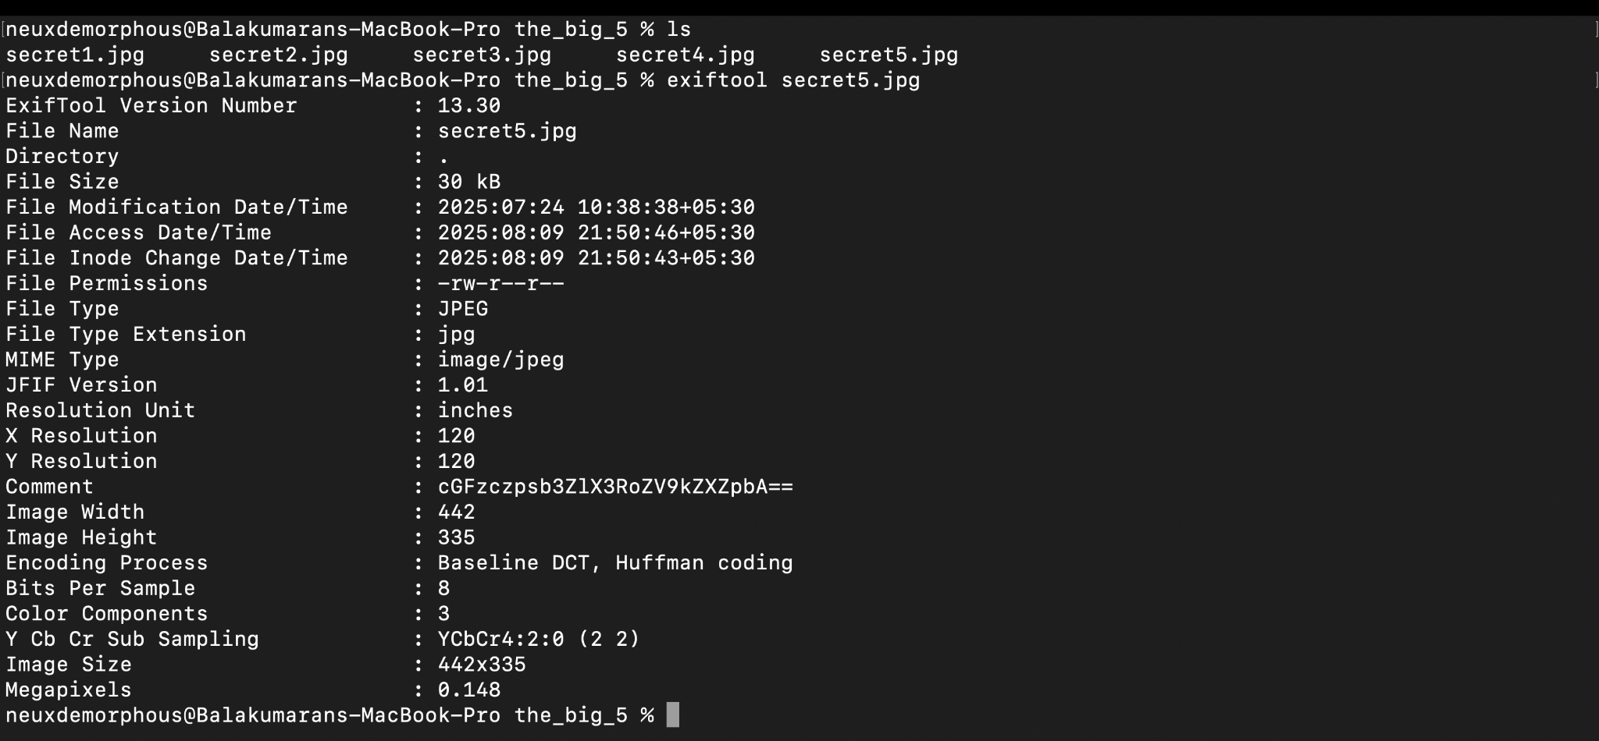**using exiftool we see a user comment of secret5.jpg**

**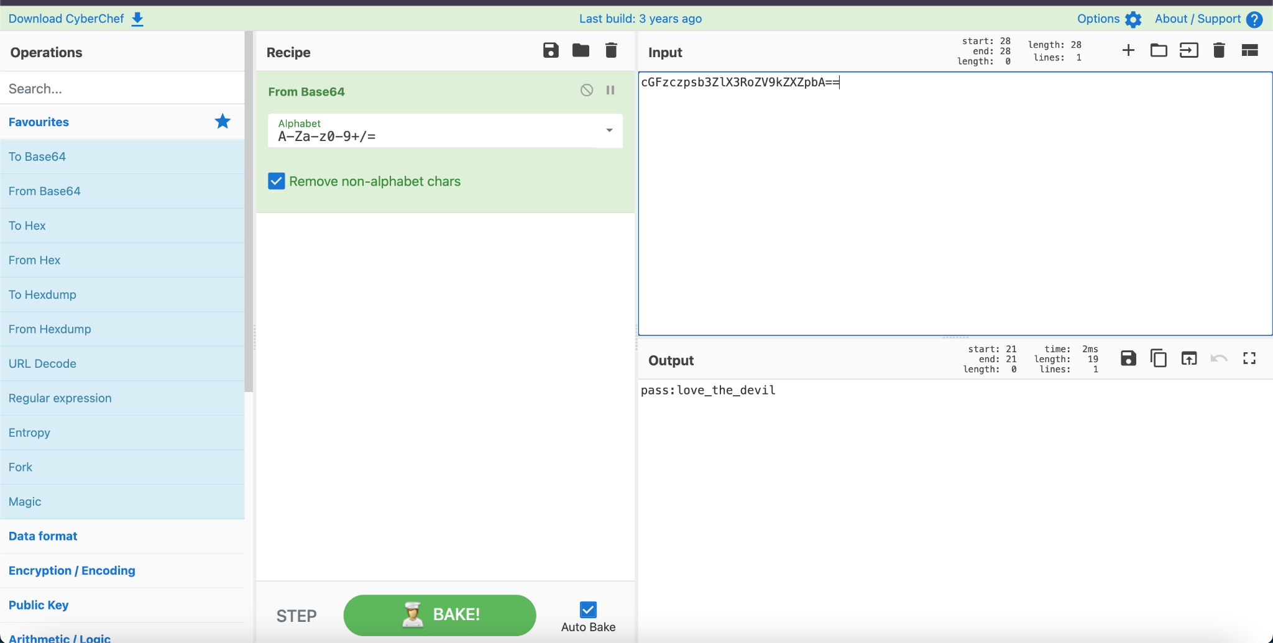  
We got some password seems like we can use it somewhere??? But where?**

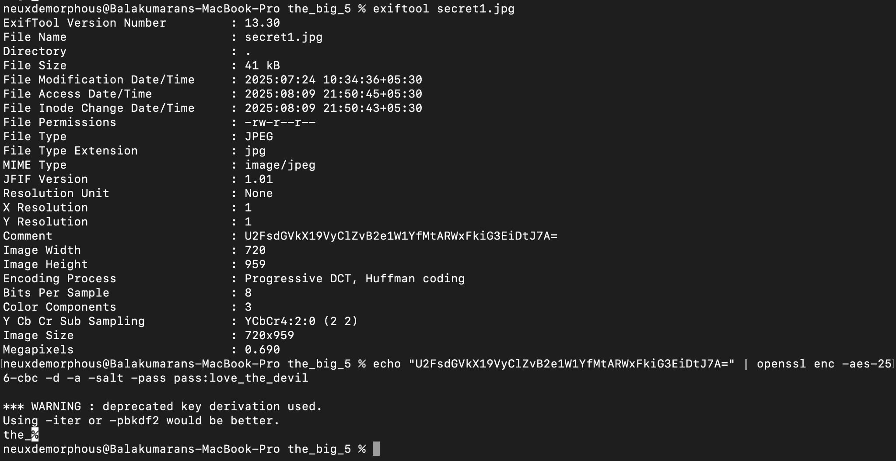

**Using exiftool i can see that they are password protected and guess what we already have the password soo yea its as simple as that get the password and run a openssl to decrypt it**

Flag:

**8. True Love**

Difficulty: Medium/ 400 points

**Description:**

love love love strange love…

**Solution:**

Flag: